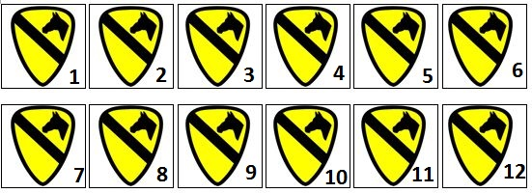
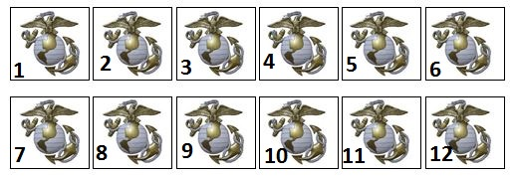
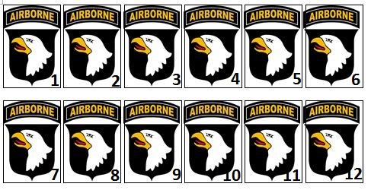
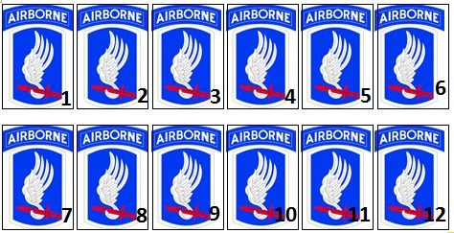
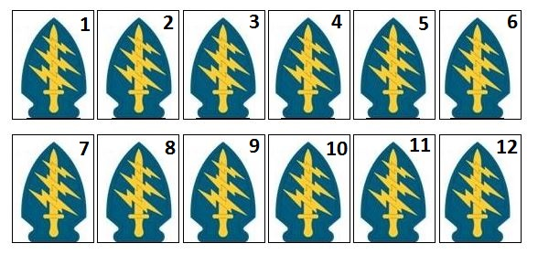
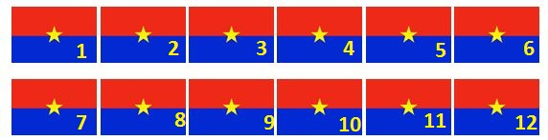
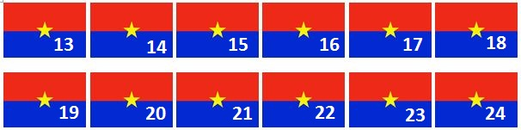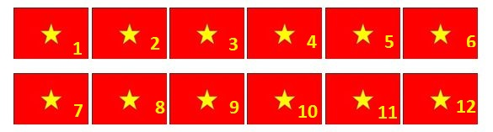

A genoux | A genoux | A genoux | A genoux | A genoux | A genoux
A plat ventre | A plat ventre | A plat ventre | A plat ventre | A plat ventre | A plat ventre
A genoux | A genoux | A genoux | A genoux | A genoux | A genoux
A plat ventre | A plat ventre | A plat ventre | A plat ventre | A plat ventre | A plat ventre

